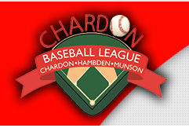
Registration is open for Chardon Baseball League’s 2018 Season for players ages 4-17! Register online NOW at http://www.chardonbaseball.com
Important CBL 2018 season information, dates and registration deadlines noted on the website. Late registrations are not guaranteed and additional fees may apply.
Coaching, volunteering and sponsorship opportunities available. Join the fun!

